WATERLOO INVESTMENT HOLDINGS LIMITED ANNOUNCES THE RESULTS FOR THE SIX-MONTH PERIOD ENDED SEPTEMBER 30, 2025

December 17, 2025 – Waterloo Investment Holdings Limited (Bermuda – WIHL) (“the Company” or “WIHL”) announces the release of its Half-Year Results as at and for the period ended September 30, 2025. The Company reports net income of $35.8m for the six months ended September 30, 2025 (2024 – $39.9m) and net income per ordinary share for the year of $0.06 (2024 – $0.06).

At September 30, 2025 total assets were $2,266.2m (March 31, 2025 - $2,249.4m) and net assets were $1,179.8m (March 31, 2025 - $1,144.6m).

A copy of the Half-Year Results will be made available for download from the Company’s website: http://www.wihl.com or from the Company’s Listing Sponsor, Ocorian Securities (Bermuda) Limited of Victoria Place, 5th Floor, 31 Victoria Street, Hamilton, HM GX, Bermuda.

Background

Waterloo Investment Holdings Limited is a BVI business company with registered number 1628508 and registered office at Craigmuir Chambers, Road Town, Tortola, British Virgin Islands (“Waterloo” or "WIHL").
WIHL is an international company with significant investments in the Caribbean and Latin America. Its operating businesses are mainly concentrated in the finance and hospitality sectors of Belize and the Turks and Caicos Islands.

Waterloo's principal banking subsidiaries comprise of The Belize Bank Limited and Belize Bank International Limited in Belize and British Caribbean Bank Limited in the Turks and Caicos Islands. Belize Bank is the market leader in Belize where it is the largest, full service commercial and retail banking operation in the country, with twelve branches. Belize Bank International is an international bank offering services to international clients. British Caribbean Bank provides banking and investment services to both local and international clientele in Turks and Caicos.

For further information contact:

Waterloo Investment Holdings Limited at 101 Governors Road, Leeward, Providenciales, Turks & Caicos Islands, B.W.I. or send an email via the Company’s
web site http://www.wihl.com.

Waterloo Investment Holdings Limited
Financial Information
Summarized Consolidated Balance Sheet (unaudited)
US dollars in millions

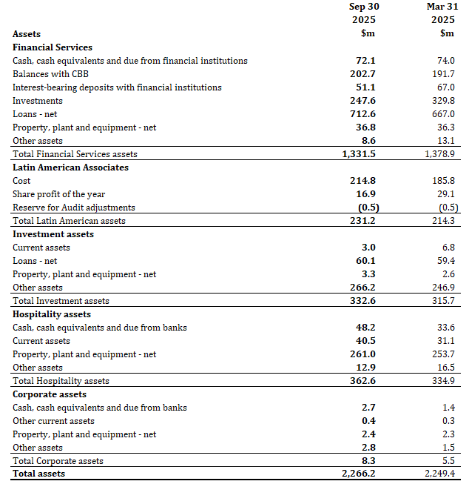
Waterloo Investment Holdings Limited
Financial Information
Summarized Consolidated Balance Sheet (continued)
US dollars in millions

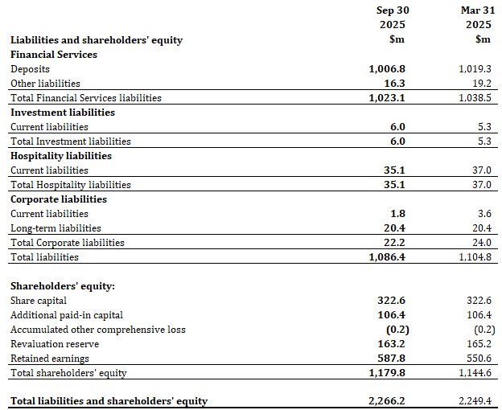

Waterloo Investment Holdings Limited
Financial Information
Summarized Consolidated Statements of Comprehensive Income (unaudited)
US dollars in millions except per share data

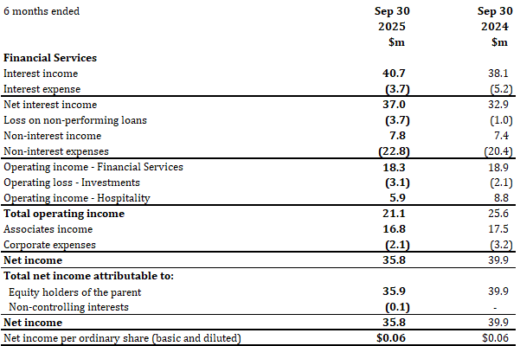

Waterloo Investment Holdings Limited
Financial Information
Summarized Consolidated Statements of Cash Flows (unaudited)
US dollars in millions

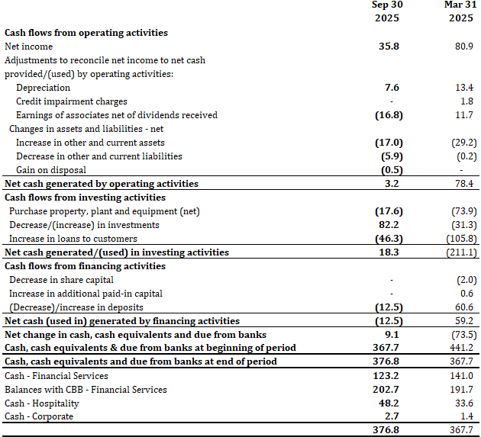

-ENDS-

